Latha Mathavan Engineering College
Madurai - 625301

Approved by AICTE, New Delhi and Affiliated to Anna University, Chennai

Subject Name : ServiceNow Administrator (NM1051) (Under Naan Mudhalvan Scheme)

Project Title : Laptop Request Catalog Item
Team ID: NM2025TMID06107
Team Members
M.Raguvaran - 911022104056
M.Prakashan – 911022104054
G.Naveenkumar - 911022104043
O.Subash – 911022104071
Laptop Request Catalog Item
- Objective
Enable employees to request laptops through a standardized, user-friendly interface. Trigger workflows for manager approval, asset assignment, and delivery. Capture justification, asset details, and maintain audit trails for IT governance.
- Introduction
The Laptop Request catalog item provides employees with a streamlined, self-service interface to request new or replacement laptops.
Designed to enhance operational efficiency and user satisfaction, this item simplifies the process of selecting preferred device configuration, submitting justifications, and initiating approval workflows.
By integrating with ServiceNow’s Asset Management and Procurement modules, it ensures accurate tracking, and compliance with organizational policies.
- Project Scope
- Design and deploy
- Automate workflows
- Integrate with Asset Management
- Tools and Technologies Used
Tool/Technology | Description
- Catalog Item Designer | Builds the laptop request form
- Flow Designer | Automates approvals and fulfillment
- Asset Management | Tracks inventory and assignments
- ServiceNow Asset Management | Tracks laptop inventory, assignment, and lifecycle status.
- ServiceNow CMDB | Links laptops to configuration items
- ACLs | Controls access and visibility
- Problem Statement
Employees in the organization need a quick and efficient way to request laptops for work. The current process is manual and prone to delays, with no dynamic form behavior to guide users or ensure accurate data collection. The solution should also ensure all changes are tracked for governance and deployment.
- System Requirements
Hardware Requirements
• Processor: Dual Core or higher
• RAM: Minimum 4 GB
• Internet Connection: Stable broadband

Software Requirements
• Web Browser (Google Chrome preferred)
• ServiceNow Developer Instance
• ServiceNow Account (developer.servicenow.com)
- Project Implementation Steps
Step 1: Setting up ServiceNow Instance
- Visit https://developer.servicenow.com
- Sign up for a free developer account.
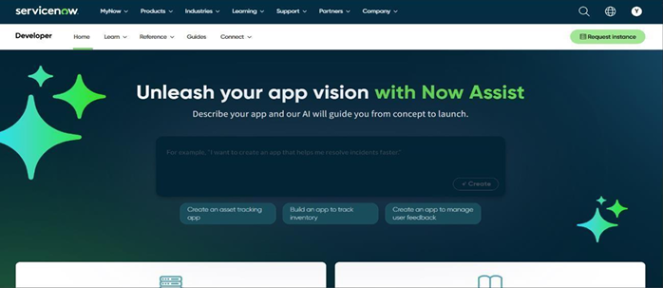
- Log in to your instance to start customizing.

Step 2: Create Local Update set
1. Navigate to All → Local Update Sets → New
2. Enter details:
- Name: “Laptop Request”
3. Click Submit and Make Current
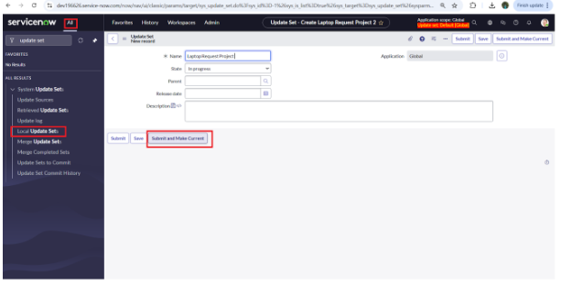
This ensures all future configurations are captured under the same update set.

Step 3 : Create Service Catalog Item
- Navigate to All - service catalog
- Select maintain items under catalog definitions
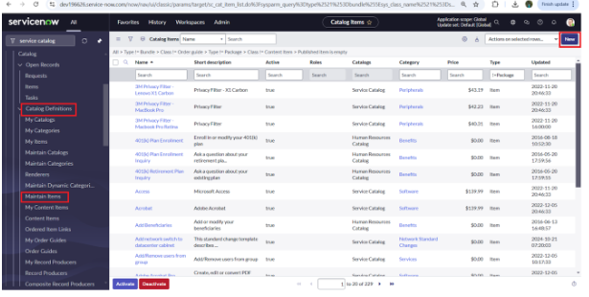
- Click on New.

- Fill the following details to create a new catalog item
Name : Laptop Request
Catalog : service Catalog
Category : Hardware
Short Description : Use this item to request a new laptop
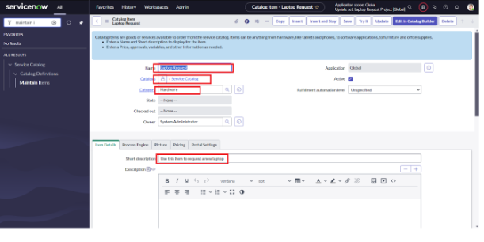
- Click on ‘SAVE’
Step 4 : Add variables
- After saving the catalog item form scroll down and click on variable(related list)
- Click on new and enter the details as below
1. Variable 1:Laptop Model
Type: Single line text
Name: laptop_model
Order:100
- Click on submit
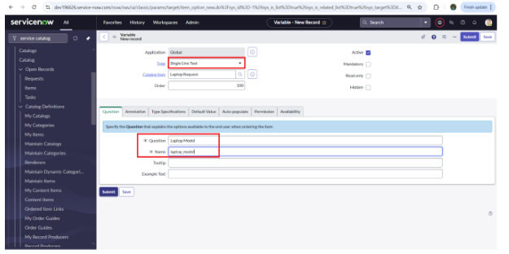
- Again click on new and add Remaining variables in the above process
2. Variable 2:Justification
Type: Multi line text
Name: justification
Order:200
3. Variable 3:Additional Accessories
Type: Checkbox
Name: additional_accessories
Order:300
4. Variable 4: Accessories Details
Type: Multi line text
Name:accessories_details
Order:400
- After adding above variable which are added to newly created catalog item
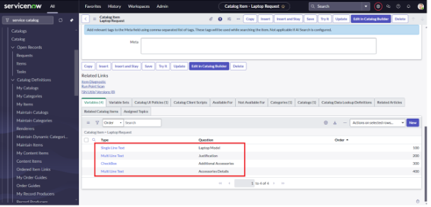
- Then save the catalog item form
Step 5 : Create Catalog Ui policies
- scroll down click on “Catalog Ui policies”
- In the catalog ui policies related list tab click on new
- Give short description as: show accessories details
- Set the Catalog Condition in the related list tab ‘when to apply’
[field: additional_ accessories, operator: is, value: true]
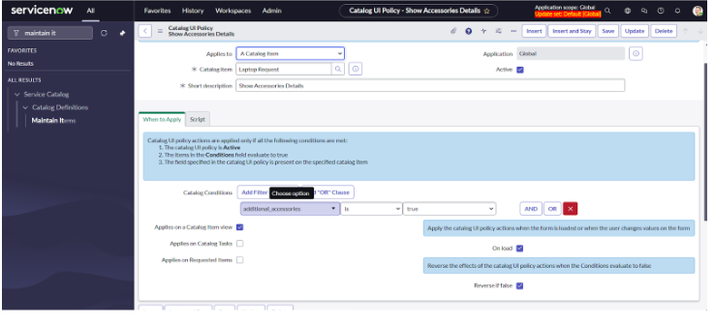
- Click on save.(do not click on submit)
- Scroll down and select ‘catalog ui action’
- Then click on new button
- Select variable name as: accessories_details
Order:100
Mandatory: True
Visible : True
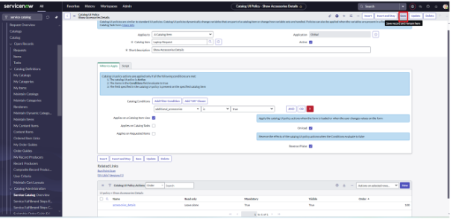
- Click on save and again click save button of the catalog ui policy form

Step 6 : Create ui action
- Navigate To All → search for ui action / system definition → Select ui actions
- Click on new
- Fill the following details to create ui action
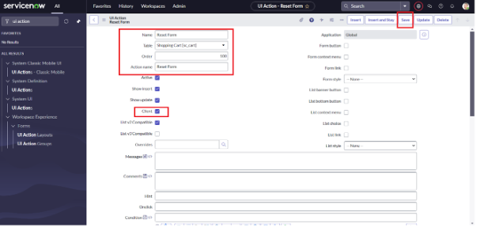
- Table: shopping cart(sc_cart)
Order:100
Action name: Reset form
Client : checked
Script:
function resetForm() {
g_form.clearForm(); // Clears all fields in the form
alert("The form has been reset.");
}
• Click on save

Step 7 : Exporting changes to another instances
- Navigate To All → local update set
- Select created update set i.e. ‘Laptop Request Project’
- Set the state ‘In Progress’ → ‘Complete’
- In the related list Update tab, updates are visible which we perform under this update set.
- Click on export to XML ,it download one file
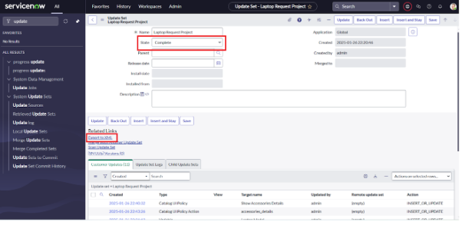

Step 8 : Test Catalog Item
- Navigate to All → Service Catalog
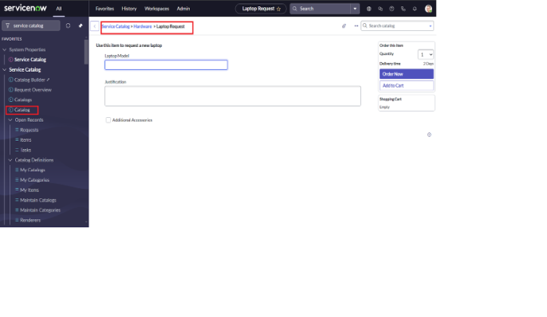
- Select Hardware → search “laptop request”

- Select Laptop Request and it’s show three variables
- Check the all instruction
- Click order now to Final validation

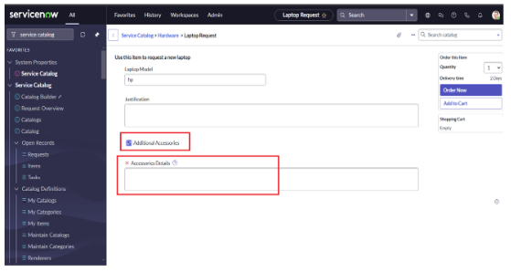
- Conclusion
- The Laptop Request Catalog Item project successfully streamlines the process of requesting laptops within the organization by leveraging ServiceNow's Service Catalog capabilities.
- Through the implementation of a dynamic catalog item, the project ensures that users have an intuitive and user-friendly interface, reducing errors and improving efficiency.
- This project demonstrates how ServiceNow can be used to replace manual, error-prone processes with automated, efficient, and user-centric solutions.
- It not only improves service delivery but also enhances employee satisfaction by providing a modern and streamlined request experience.

